***Report:***



***EDC PROJECT***

**(EMERGENCY/AUTOMATIC STREET LIGHT SYSTEM (USING INTENSITY OF LIGHT))**

**ROLL NO:** *BSEE-21005*

**NAME:** *FURQAN BARI*

**ROLL NO:** *BSEE-21080*

**NAME:** *Abdul Rahman*

**COURSE INSTRUCTURE:** *SIR HUSSIAN RIAZ*

**DEPARTMENT:** *ELECTRICAL ENGINEERING*

**SEMESTER:** *2*

**LAB INSTRUCTURE:** *ASIF ALI*

# ***ABSTRACT:***

*The Main objective of the our project is to make a basic automatic/emergency light system by using the intensity of the light. In this system, if the intensity of light is greater from specific value of resistance (from 3) in system no light turns on. If intensity decreases first light turn on and more intensity decreases more lights turn on and so on. This project has vast applications in street lights and our homes also many other companies.*

**Table Of Contents**

***ABSTRACT:*** i

**LIST OF FIGURES:** ii

***CHAPTER 1:*** 1

***CHAPTER 2:*** 1

***CHAPTER 3:*** 2

***CHAPTER 4:*** 3

***CHAPTER 5:*** 5

***REFERENCES:*** 5

***PLAGRISIM:*** 5

# **LIST OF FIGURES:**

Figure 3.1 : Simulation Diagram 2

Figure 3.2 : List Of Components 3

Figure 4.1: Sample of our One LED Circuit 4

Figure 4.2: Our three way automatic light system 4

Figure 5.1:Plagrisim Check 4

# ***CHAPTER 1:***

***INTRODUCTION***

Our project of emergency light system is used as street lights and in houses, offices e.tc. Our project turn on the lights automatically depending upon the intensity of light which is proportional to the variable resistance at certain values. Our project has the ability to compare the resistance of LDR (which give the high resistance as the intensity decreases).

RESISTENCE IS PROPORTIONAL TO INTENSITY OF LEIGHT OF **LDR.**

It has vast applications in future and till now. It’s mechanism is very simple and it is easy to use and make.

# ***CHAPTER 2:***

***LITERATURE REVIEW***

In our Project we initially gave the 12V to our circuit and also to the output Led’s. We use the Comparators to compare the voltages of the LDR and the voltage difference of the Potentiometer. We set the resistances of potentiometer different. So, it gives different Voltages to the comparator + terminal and we set the voltages of the LDR to the – terminal of the comparator. We set the 10K Potentiometer which is connected to the Vcc and Vee and the middle of it connected to the + terminal of the IC. After comparing the voltages of the comparator show the output as if + is greater than negative then Vcc out and if – is greater then Vee out to the Led of 1.28V of red colour, connected to a resister of 250 ohm. – output shows no turn on the led and + output turn on the light.

# ***CHAPTER 3:***

***IN DEPTH INFORMATION***

In our Project we use 12V voltage source battery with the LDR and some resistors in which LDR connected to the 12V battery positive terminal and 1 k resistor connected to the LDR and with ground. From middle we extract an voltage to all the – terminals of our IC. + terminals connected to the middle of the Potentiometer. Which compare the voltages at terminals and give output according to the max voltage terminal. Its simulation diagram is:

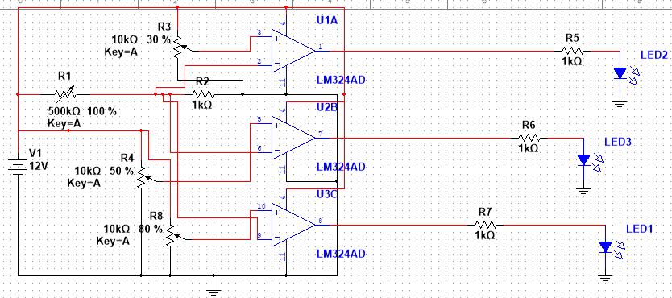

Figure 3.1 : Simulation Diagram

All the components used are:

|  |  |  |
| --- | --- | --- |
| **Components** | **Model** | **Quantity** |
| LDR | **-** | 1 |
| Resistor’s | 1k , 250k | 1,3 |
| Variable Resistor | 10k | 3 |
| OP-Amp | LM324N | 1 |
| Led’s | 1.28 V | 3(RED) |
| Battery | 12 V | 1 |

Figure 3.2 : List Of Components

# ***CHAPTER 4:***

***EXPERIMENTS AND RESULTS***

Then we implement our multisim diagram in to our breadboard, connect all the circuits make wirings and set the potentiometer according to the scales given in back chapters. While doing our experiments we broke our some Led’s and IC also with our one potentiometer, due to the less current with high voltage given to the circuit by using multimeter given from our lab. Then finally we made our fully functional circuit on real. Now, when we block the light from LDR it makes the circuit to turn on the one LED. If more light intensity blocked it will make another LED turn on.

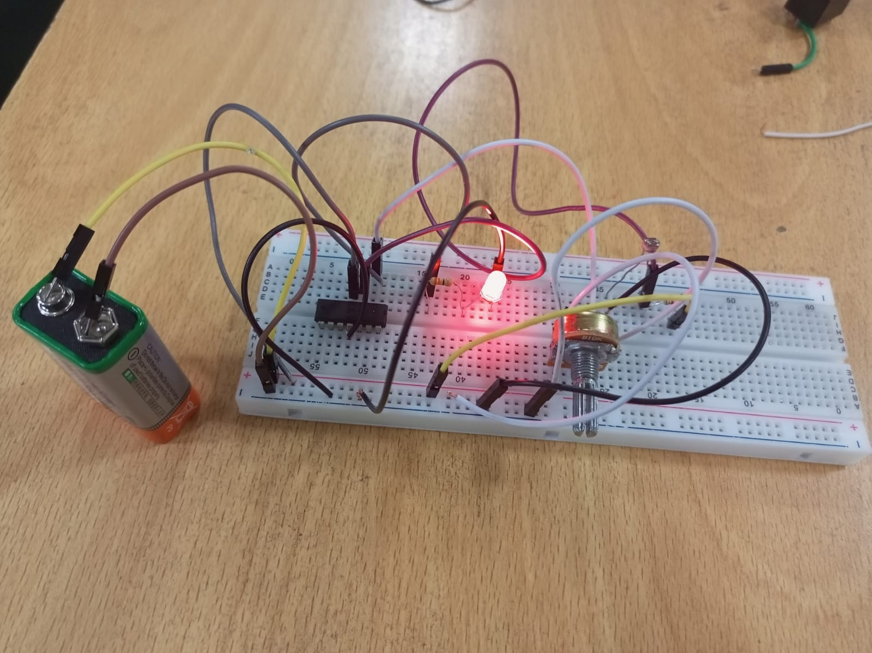

Figure 4.1: Sample: Our One LED Circuit

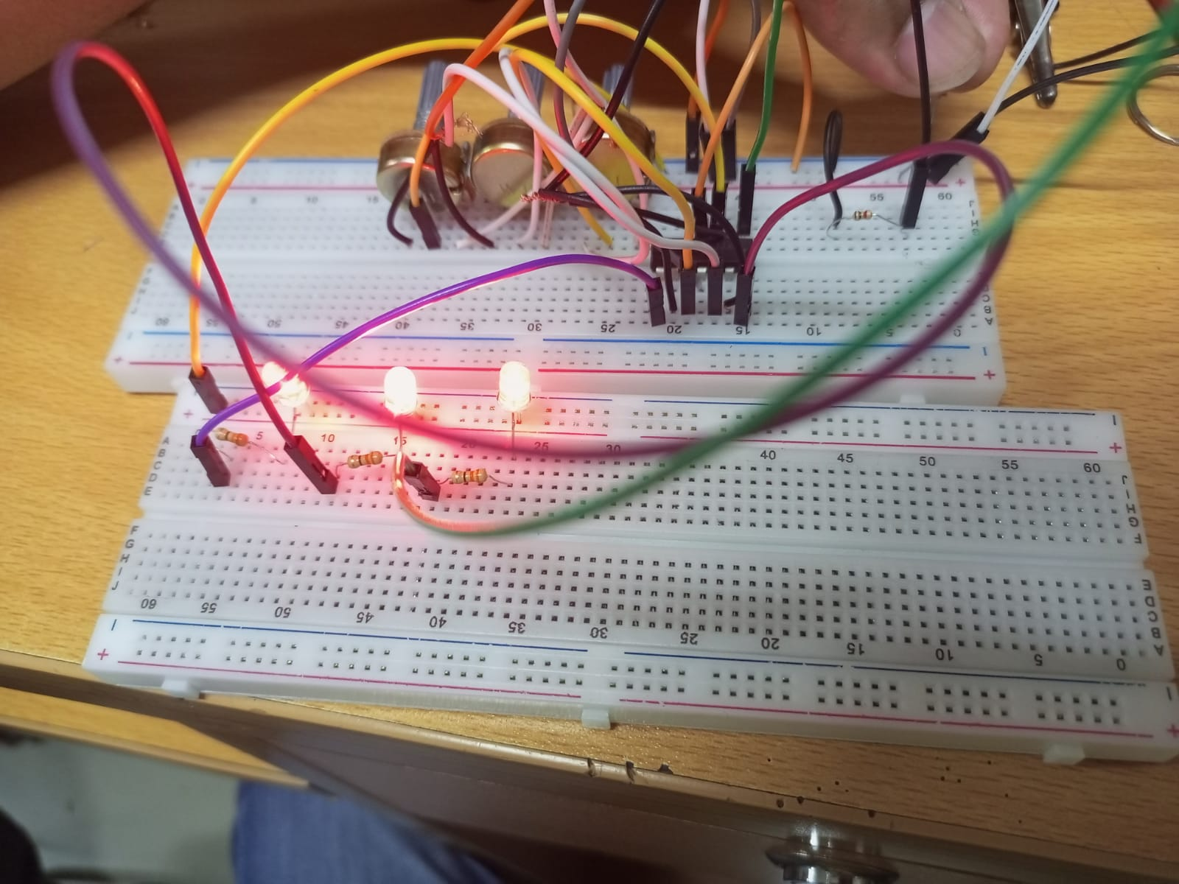

Figure 3.2: Our three way automatic light system

# ***CHAPTER 5:***

***CONCLUSION AND RECOMMENDATION***

Our Circuit is very useful in industrial scale, as street Lights, in house systems and in offices e.tc. It has vast applications. And in future we also add in this system an AC and DC power sources. If Ac source cutoff, then yet it works with Dc source connected to it. Which is charge by an Ac source when it is available. We can also add and solar system to it, when our circuit is used as street light and as our in houses. So it becomes energy efficient device.

# ***REFERENCES:***

**From no where**

# ***PLAGRISIM:***

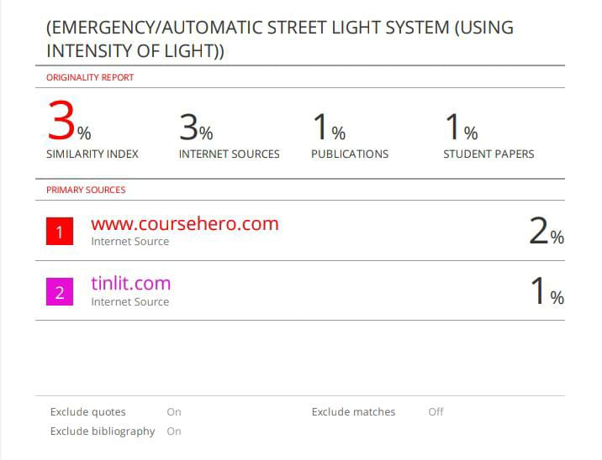

FIG 5.1: PLAGERISIM CHECK